Android Layouts:

Linear Layout, Relative Layout and Table Layout

Android allows you to create view layouts using simple XML file (we can also create a layout using java code). All the layouts must be placed in */res/layout* folder.

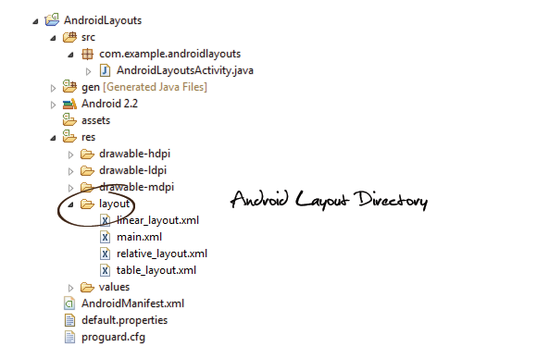

Okay, now lets get started with the view layouts.

1. Linear Layout

In a linear layout, like the name suggests, all the elements are displayed in a linear fashion(below is an example of the linear layouts), either *Horizontally* or *Vertically* and this behavior is set in *android:orientation* which is an attribute of the node LinearLayout.

Example of Vertical layout snippet

|  |
| --- |
| <LinearLayout android:orientation="vertical"> .... </LinearLayout> |

Example of Horizontal layout snippet

|  |
| --- |
| <LinearLayout android:orientation="horizontal"> .... </LinearLayout> |

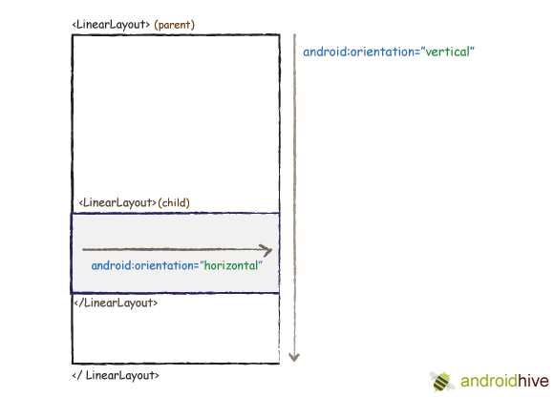

Now that we know the two types of linear layouts, here are the steps you need to follow to create them

**1**. Create a new project **File -> New -> Android Project**  
**2**. In Package Explorer right click on *res/layout* folder and create a new Android XML File and name it as you wish. I am naming it as “*linear_layout.xml*”  
**res/layout -> Right Click -> New -> Android XML File**  
**3**. Now open newly created xml file (in my case “*linear_layout.xml*”) and type the following code.

|  |
| --- |
| <?xml version="1.0" encoding="utf-8"?>  <!-- Parent linear layout with vertical orientation -->  <LinearLayout    xmlns:android="<http://schemas.android.com/apk/res/android>"    android:orientation="vertical"    android:layout_width="match_parent"    android:layout_height="match_parent">      <TextView android:layout_width="fill_parent" android:layout_height="wrap_content"              android:text="Email:" android:padding="5dip"/>      <EditText android:layout_width="fill_parent" android:layout_height="wrap_content"              android:layout_marginBottom="10dip"/>      <Button android:layout_width="fill_parent" android:layout_height="wrap_content"              android:text="Login"/>      <!-- Child linear layout with horizontal orientation -->    <LinearLayout android:layout_width="fill_parent"                        android:layout_height="wrap_content"                android:orientation="horizontal" android:background="#2a2a2a"                android:layout_marginTop="25dip">      <TextView android:layout_width="fill_parent" android:layout_height="wrap_content"           android:text="Home" android:padding="15dip" android:layout_weight="1"           android:gravity="center"/>      <TextView android:layout_width="fill_parent" android:layout_height="wrap_content"           android:text="About" android:padding="15dip" android:layout_weight="1"           android:gravity="center"/>      </LinearLayout>    </LinearLayout> |

**4**. To set this newly created view as the initial view of your app, Open your MainActivity.java file. You would see the following line inside the *onCreate* function *setContentView(R.layout.main)*. Change *R.layout.main* to *R.layout.yourlinearviewname*. In my case its *R.layout.linear_layout*

|  |
| --- |
| package com.example.androidlayouts;  import android.app.Activity;  import android.os.Bundle;    public class AndroidLayoutsActivity extends Activity {        @Override      public void onCreate(Bundle savedInstanceState) {          super.onCreate(savedInstanceState);          setContentView(R.layout.linear_layout);      }  } |

**5**. To run the application, **right click on the project -> Run As -> 1. Android Application**. You should see your newly created linear layout in the emulator.

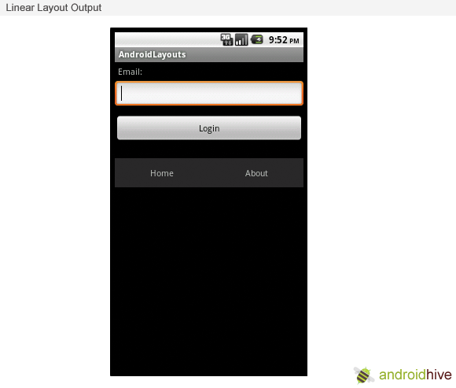

2. Relative Layout

In a relative layout every element arranges itself relative to other elements or a parent element.  
As an example, lets consider the layout defined below. The “*Cancel*” button is placed relatively, to the *right of* the “*Login*” button *parallely*. Here is the code snippet that achieves the mentioned alignment (Right of Login button parallely)

Example code snippet

|  |
| --- |
| <Button android:id="@+id/btnLogin" ..></Button>    <Button android:layout_toRightOf="@id/btnLogin"              android:layout_alignTop="@id/btnLogin" ..></Button> |

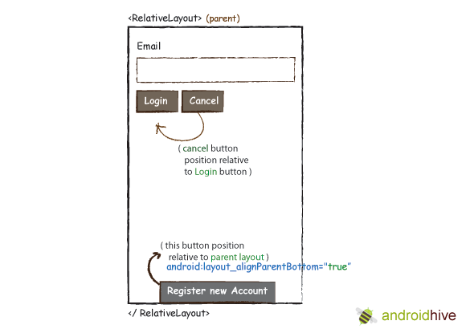

Here are the steps to create a relative layout

**1**. Create a new project File -> New -> Android Project  
**2**. In Package Explorer right click on *res/layout* folder and create a new Android XML File and name it as you wish. I am naming it as “relative_layout.xml”  
**res/layout -> Right Click -> New -> Android XML File**  
**3**. Now open newly created xml file (in my case “*relative_layout.xml*”) and type the following code.

|  |
| --- |
| <?xml version="1.0" encoding="utf-8"?>  <RelativeLayout xmlns:android="<http://schemas.android.com/apk/res/android>"                  android:layout_width="fill_parent"                  android:layout_height="wrap_content">        <TextView android:id="@+id/label" android:layout_width="fill_parent"                android:layout_height="wrap_content" android:text="Email" />        <EditText android:id="@+id/inputEmail" android:layout_width="fill_parent"                android:layout_height="wrap_content" android:layout_below="@id/label" />        <Button android:id="@+id/btnLogin" android:layout_width="wrap_content"              android:layout_height="wrap_content" android:layout_below="@id/inputEmail"              android:layout_alignParentLeft="true" android:layout_marginRight="10px"              android:text="Login" />        <Button android:layout_width="wrap_content" android:layout_height="wrap_content"              android:layout_toRightOf="@id/btnLogin"              android:layout_alignTop="@id/btnLogin"  android:text="Cancel" />        <Button android:layout_width="wrap_content" android:layout_height="wrap_content"              android:layout_alignParentBottom="true" android:text="Register new Account"              android:layout_centerHorizontal="true"/>  </RelativeLayout> |

4. Same like before open your MainActivity.java file and set the layout to your newly created relative layout file. In my case its *R.layout.relative_layout*

|  |
| --- |
| setContentView(R.layout.relative_layout); |

5. To run the application, **right click on the project -> Run As -> 1. Android Application**. You should see your newly created relative layout in the emulator.

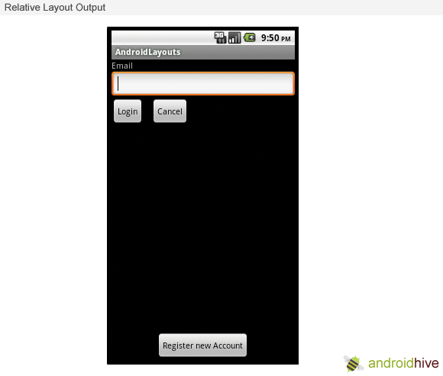

3. Table Layout

Table layouts in Android works in the same way HTML table layouts work. You can divide your layouts into *rows* and *columns*. Its very easy to understand. The image below should give you an idea.

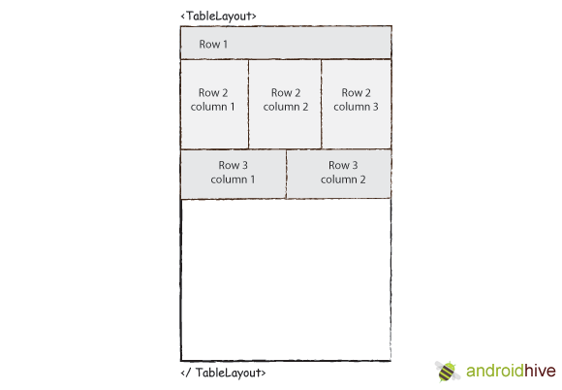

**1**. Create a new project **File -> New -> Android Project**  
**2**. In Package Explorer right click on res/layout folder and create a new Android XML File and name it as you wish. I am naming it as “table_layout.xml”  
**res/layout -> Right Click -> New -> Android XML File**  
**3**. Now open newly created xml file (in my case “*table_layout.xml*”) and type the following code.

|  |
| --- |
| <TableLayout      xmlns:android="<http://schemas.android.com/apk/res/android>"      android:layout_width="match_parent"      android:layout_height="match_parent"      android:shrinkColumns="*"  android:stretchColumns="*" android:background="#ffffff">      <!-- Row 1 with single column -->      <TableRow          android:layout_height="wrap_content"          android:layout_width="fill_parent"          android:gravity="center_horizontal">          <TextView              android:layout_width="match_parent" android:layout_height="wrap_content"              android:textSize="18dp" android:text="Row 1"  android:layout_span="3"              android:padding="18dip" android:background="#b0b0b0"              android:textColor="#000"/>      </TableRow>        <!-- Row 2 with 3 columns -->      <TableRow          android:id="@+id/tableRow1"          android:layout_height="wrap_content"          android:layout_width="match_parent">          <TextView              android:id="@+id/TextView04" android:text="Row 2 column 1"              android:layout_weight="1" android:background="#dcdcdc"              android:textColor="#000000"              android:padding="20dip" android:gravity="center"/>          <TextView              android:id="@+id/TextView04" android:text="Row 2 column 2"              android:layout_weight="1" android:background="#d3d3d3"              android:textColor="#000000"              android:padding="20dip" android:gravity="center"/>          <TextView              android:id="@+id/TextView04" android:text="Row 2 column 3"              android:layout_weight="1" android:background="#cac9c9"              android:textColor="#000000"              android:padding="20dip" android:gravity="center"/>      </TableRow>        <!-- Row 3 with 2 columns -->      <TableRow          android:layout_height="wrap_content"          android:layout_width="fill_parent"          android:gravity="center_horizontal">          <TextView              android:id="@+id/TextView04" android:text="Row 3 column 1"              android:layout_weight="1" android:background="#b0b0b0"              android:textColor="#000000"              android:padding="20dip" android:gravity="center"/>            <TextView              android:id="@+id/TextView04" android:text="Row 3 column 2"              android:layout_weight="1" android:background="#a09f9f"              android:textColor="#000000"              android:padding="20dip" android:gravity="center"/>      </TableRow>    </TableLayout> |

**4**. Same like before open your MainActivity.java file and set the layout to your newly created table layout file. In my case its *R.layout.table_layout*

|  |
| --- |
| setContentView(R.layout.table_layout); |

5. To run the application, **right click on the project -> Run As -> 1. Android Application**. You should see your newly created table layout in the emulator.

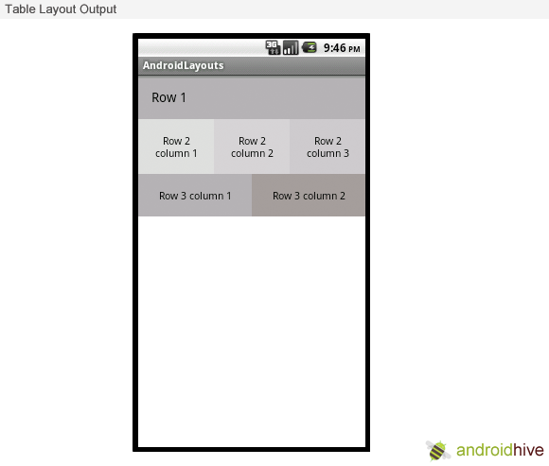

I have just discussed **Linear Layout, Relative Layout** and **Table Layout** in this post. The remaining **Grid View, Tab Layout** and **List View** will be covered in the next article. Stay tuned!